Project Design Phase-II
Technology Stack (Architecture & Stack)
Date | 28 September 2026
Team ID | 6ab221fbe880316a482c6241
Project Name | Script-Controlled ACL – Restrict Record Access Based on Field Value
Maximum Marks | 4 Marks
Technical Architecture:
The Deliverable shall include the architectural diagram as below and the information as per the table 1 & table 2
Example: Script-controlled ACL for restricting record access to the EEE branch
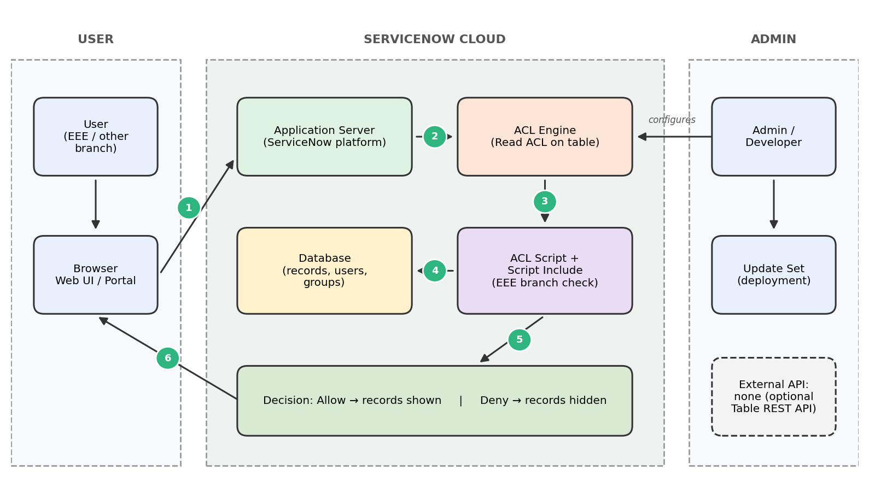
Guidelines:
Include all the processes (as an application logic / technology block)
Provide infrastructural demarcation (local / cloud)
Indicate external interfaces (third party APIs etc.)
Indicate data storage components / services
Indicate interface to machine learning models (if applicable)
Table-1 : Components & Technologies:
S.No | Component | Description | Technology
1. | User Interface | How the user interacts with the application, i.e. Web UI to open the records list and form | ServiceNow Next Experience UI / Service Portal, HTML, CSS, JavaScript (client scripts)
2. | Application Logic-1 | Read ACL on the records table that decides whether a record can be viewed | ServiceNow Access Control (ACL), server-side JavaScript
3. | Application Logic-2 | ACL script that checks whether the logged-in user belongs to the EEE branch (admin bypass allowed) | GlideSystem API: gs.getUser().isMemberOf(), gs.hasRole()
4. | Application Logic-3 | Reusable branch-check logic that can be called from many ACLs | Script Include (JavaScript)
5. | Database | Stores records, users, groups and ACL configuration | ServiceNow relational database (custom records table, sys_user, sys_user_group)
6. | Cloud Database | Database service hosted on the cloud | ServiceNow cloud instance database
7. | File Storage | Attachments on records and Update Set export files | ServiceNow attachment storage, Update Set XML
8. | External API-1 | Not required. Optional REST access to the table is protected by the same ACL | ServiceNow Table REST API (optional)
9. | External API-2 | Not used in this project | N/A
10. | Machine Learning Model | Not used in this project | N/A
11. | Infrastructure (Server / Cloud) | Application deployment on the cloud.  Local Server Configuration: not required (browser only)  Cloud Server Configuration: ServiceNow instance | Cloud – ServiceNow Personal Developer Instance (PDI)
Table-2: Application Characteristics:
S.No | Characteristics | Description | Technology
1. | Open-Source Frameworks | No external open-source framework is used. The solution is built with platform-native scripting | ServiceNow platform JavaScript and Glide APIs
2. | Security Implementations | Access is controlled by ACLs with role and script conditions, group membership checks and admin bypass. Tested by impersonating EEE and non-EEE users | ServiceNow ACL, roles, groups, user authentication, HTTPS
3. | Scalable Architecture | Multi-tier cloud platform (client, application and database tiers). The same ACL pattern can be reused for other branches, tables and operations | ServiceNow multi-tier cloud architecture, Script Include
4. | Availability | The ServiceNow cloud manages availability, redundancy and backups, so no separate servers are needed. A Personal Developer Instance may hibernate when idle | ServiceNow cloud infrastructure
5. | Performance | The ACL script is kept short (a single group check) and avoids extra database queries, so record access stays fast | Lightweight ACL script, platform caching

